**DAILY ONLINE ACTIVITIES SUMMARY**

|  |  |  |  |  |  |  |  |  |
| --- | --- | --- | --- | --- | --- | --- | --- | --- |
| **Date:** | **17/07/2020** | | | | | **Name:** | **NAIPUNYA VINOD NAIK** | |
| **Sem & Sec** | **IV SEM & A SECTION** | | | | | **USN:** | **4AL18CS050** | |
| **Online Test Summary** | | | | | | | | |
| **Subject** | | **DATA COMMUNICATION** | | | | | | |
| **Max. Marks** | | **30** | | **Score** | | | **--------------------** | |
| **Certification Course Summary** | | | | | | | | |
| **Course** | 1. **LEARN PHP FOR BEGINNERS** 2. **GOOGLE CLOUD PLATFORM BIG DATA AND MACHINE LEARNING FUNDAMENTALS** | | | | | | | |
| **Certificate Provider** | | | **1)UDEMY**  **2)COURSERA** | | **Duration** | | | 1. **3 HRS** 2. **2 WEEKS** |
| **Coding Challenges** | | | | | | | | |
| **Problem Statement: NO PROBLEM STATEMENT GIVEN TODAY** | | | | | | | | |
| **Status: ------------------------** | | | | | | | | |
| **Uploaded the report in Github** | | | | | **YES** | | | |
| **If yes Repository name** | | | | | <https://github.com/naipunya-naik/daily-progress-report> | | | |
| **Uploaded the report in slack** | | | | | **YES** | | | |

Online Test Details: (Attach the snapshot and briefly write the report for the same).

TODAY DATA COMMUNICATION DESCRIPTIVE TEST-1 WAS CONDUCTED ON 17TH JULY 2020.

* SUBJECT:- DATA COMMUNICATION
* CONDUCTED BY:- MRS. VIDYA
* FROM 9.30 AM TO 10:30AM
* DURATION:- 1 HR
* NO.OF QUESTIONS:- 4
* TOTAL MARKS:- 30
* MARKS WILL BE PROVIDED SOON
* 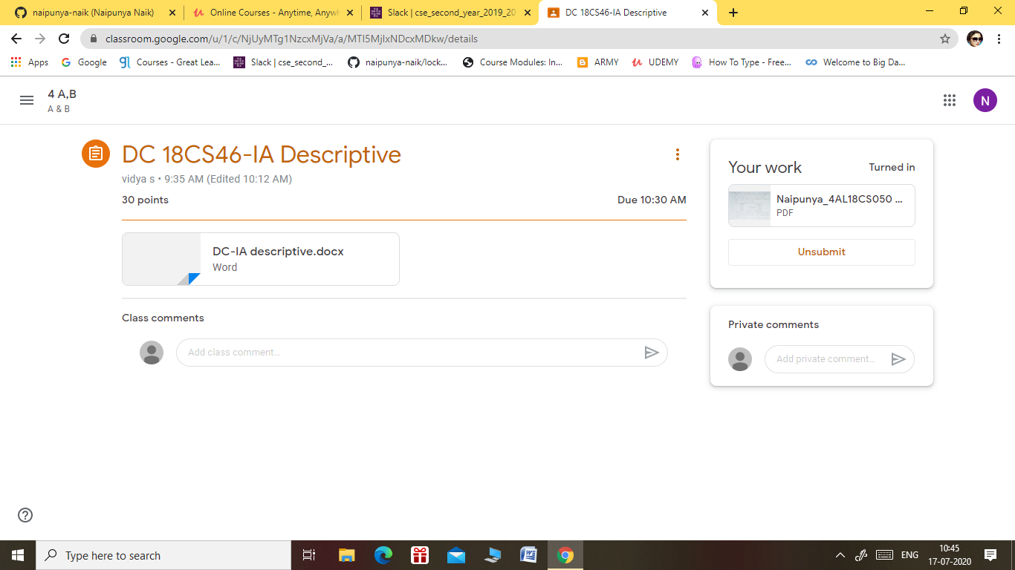

Certification Course Details: (Attach the snapshot and briefly write the report for the same).

CERTIFICATION COURSE NAME:- **LEARN PHP FOR BEGINNERS**

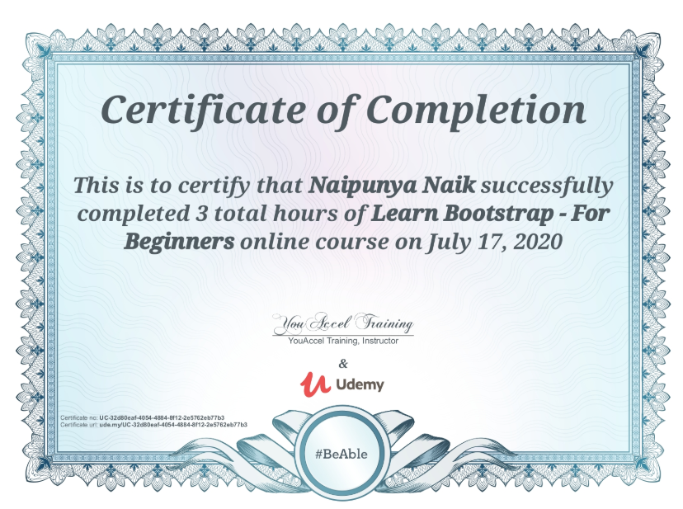

CERTIFICATION COURSE NAME:- **GOOGLE CLOUD PLATFORM BIG DATA AND MACHINE LEARNING FUNDAMENTALS**

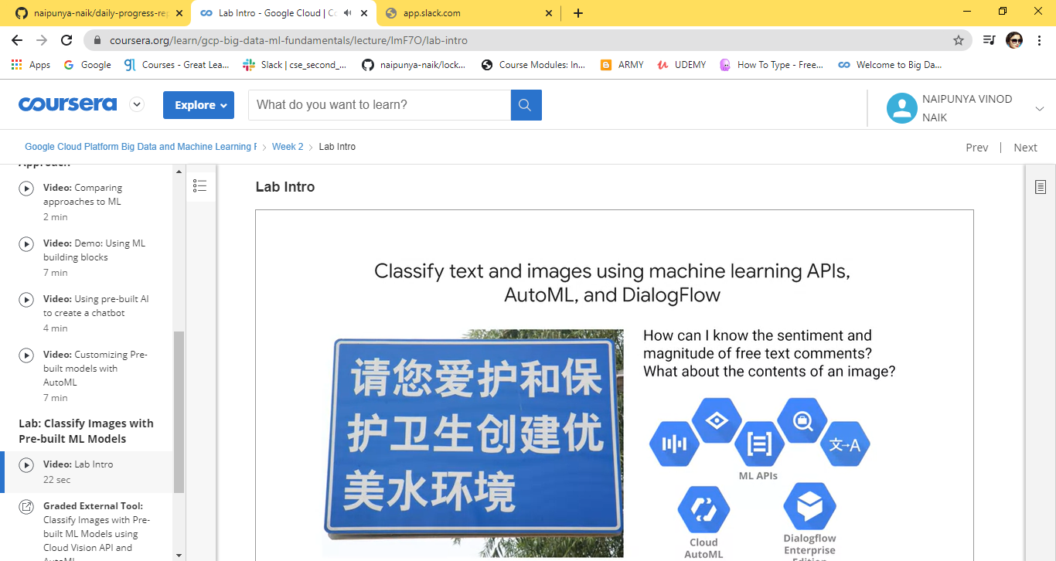

Coding Challenges Details: (Attach the snapshot and briefly write the report for the same).

**NO PROBLEM STATEMENT GIVEN TODAY**